Ordinary Least Square (OLS) Method for Linear Regression
The simple linear regression is a model with a single regressor (independent variable) x that has a relationship with a response (dependent or target) y that is a
y = β0 + β1 x + ε — — — — — — — — — — (1)
Where β0: intercept
β1: slope (unknown constant)
ε: random error component
This is a line where y is the dependent variable we want to predict, x is the independent variable, and β0 and β1 are the coefficients that we need to estimate.
Estimation of β0 and β1 :
The OLS method is used to estimate β0 and β1. The OLS method seeks to minimize the sum of the squared residuals. This means from the given data we calculate the distance from each data point to the regression line, square it, and the sum of all of the squared errors together.
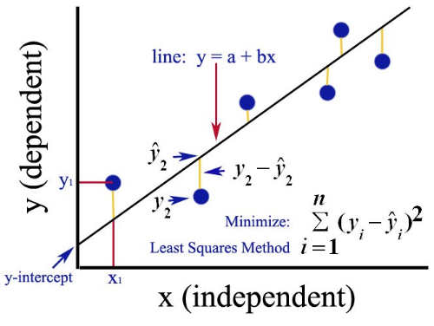
From equation (1) we may write
yi = β0 + β1 x + εi, i = 1, 2, …..n — — — — — — — — — (2)
The equation (2) is a sample regression model, written in terms of the n pairs of data (yi, xi) (i = 1, 2,……..,n). Thus, the least-squares criteria are
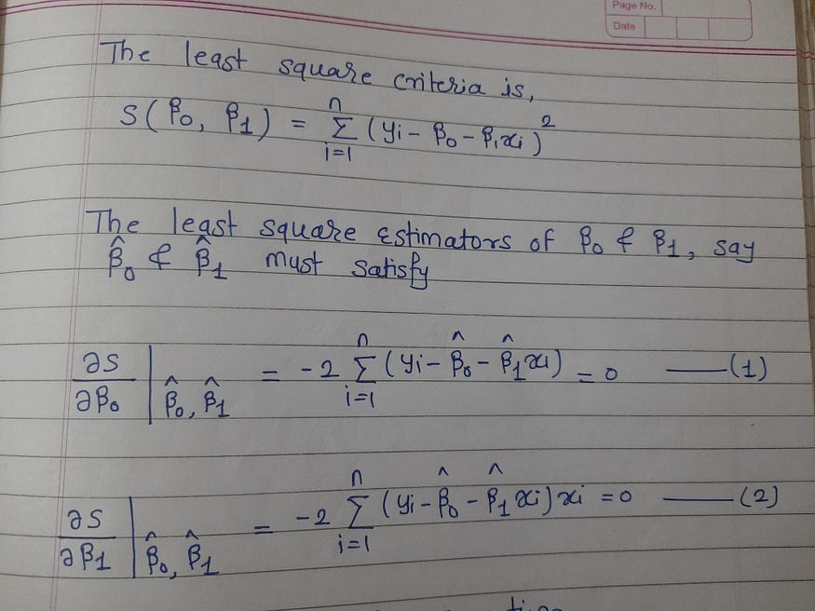
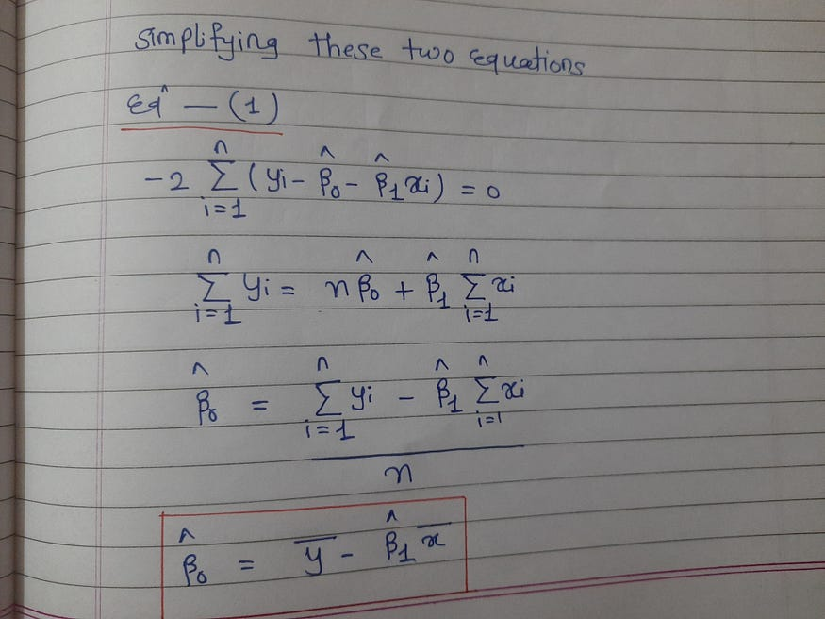
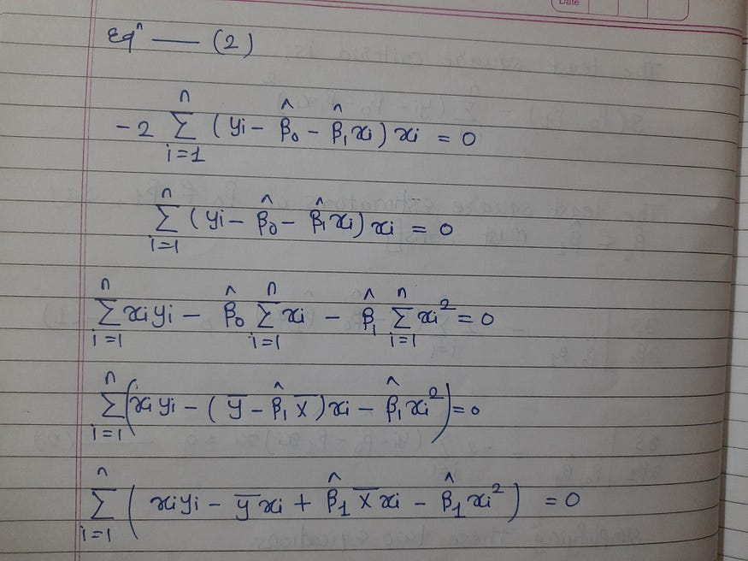
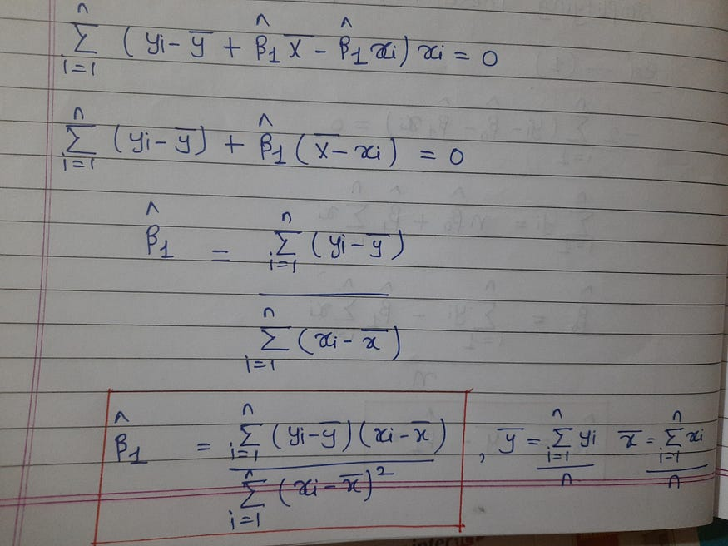
Ordinary Least Square Method
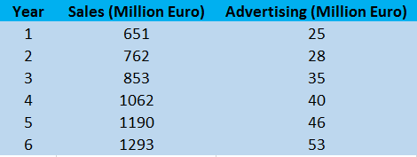
Let’s take a simple example. This table shows some data from the manufacturing company. Each row in the table shows the sales for a year and the amount spent on advertising that year. Here our target variable is sales-which we want to predict.
Linear Regression estimates that Sales = β0 + β1 * (Advertising)
Estimating the Slope ( β1):
- Calculate the mean value of x and y
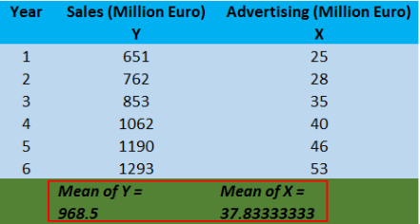
2. Calculate the error of each variable from the mean
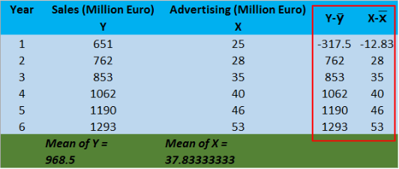
3. Multiply the error for each x with the error for each y and calculate the sum of these multiplications
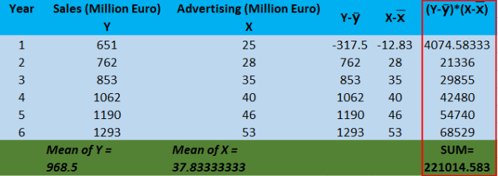
4. Square the residual of each x value from the mean and sum of these squared values
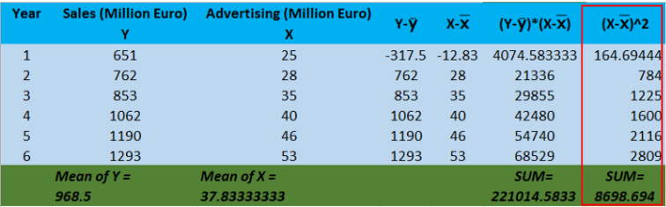
Now we have all the values to calculate the slope (β1) = 221014.5833/8698.694 = 25.41
Estimating the Intercept ( β0):
β0 = mean(y)-(β1*mean(x))
we already know all the values to calculate β0.
β0 = 968.5-(37.83333333*25.41)=7.239
Making Predictions:
Now, we have the coefficients for our simple linear regression.
y = 7.239 + 25.41* x
Let’s make predictions for our data.
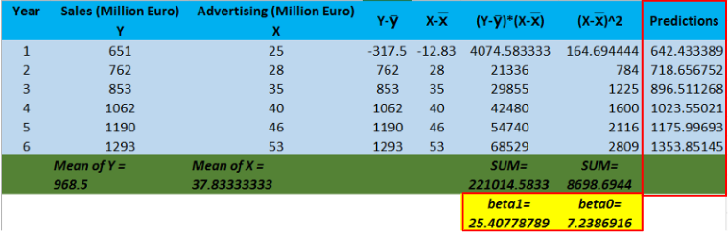
Estimating Error: Calculate the error for our predictions (Root Mean Squared Error or RMSE)
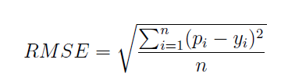
Root Mean Squared Error
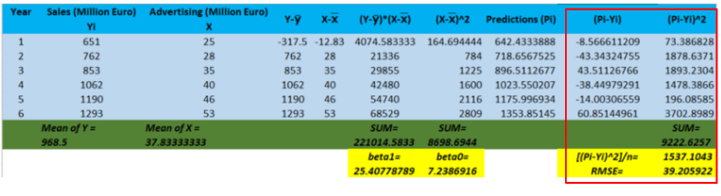
From the calculated RMSE we can say that each prediction is on average wrong by about 39.2059 units.

To calculate the slope in linear regression, we need to perform a process called "ordinary least squares" (OLS) regression. Here are the steps to calculate the slope:

- Gather your data: You should have a set of paired observations consisting of independent variable values (x) and dependent variable values (y). Ensure you have enough data points for meaningful analysis.
- Calculate the means: Find the mean (average) of both the independent variable (x) and the dependent variable (y) from your dataset. Let's call these means x̄ and ȳ, respectively.
- Calculate the deviations: Subtract the mean of x (x̄) from each x-value to get the deviation of x (xᵢ - x̄) for each data point. Similarly, subtract the mean of y (ȳ) from each y-value to get the deviation of y (yᵢ - ȳ) for each data point.
- Calculate the products: Multiply each deviation of x (xᵢ - x̄) by the corresponding deviation of y (yᵢ - ȳ) to get the product of deviations (xᵢ - x̄)(yᵢ - ȳ) for each data point.
- Calculate the sum of products: Sum up all the products of deviations (xᵢ - x̄)(yᵢ - ȳ) calculated in the previous step. Let's call this sum Sₓᵧ.
- Calculate the sum of squared deviations of x: Square each deviation of x (xᵢ - x̄) and sum up all the squared deviations. Let's call this sum Sₓ².
- Calculate the slope: Finally, calculate the slope (b) using the formula: b = Sₓᵧ / Sₓ²

Once you've completed these steps, you'll have calculated the slope (b) in linear regression. The slope represents the change in the dependent variable (y) for each unit change in the independent variable (x).
Let's assume we have n data points (xᵢ, yᵢ), where i ranges from 1 to n.
Step 1: Calculate the means:
x̄ = (1/n) * Σxᵢ (mean of x)
ȳ = (1/n) * Σyᵢ (mean of y)
Step 2: Calculate the deviations:
Deviation of x: xᵢ - x̄
Deviation of y: yᵢ - ȳ
Step 3: Calculate the sum of products:
Sₓᵧ = Σ((xᵢ - x̄) * (yᵢ - ȳ))
Step 4: Calculate the sum of squared deviations of x:
Sₓ² = Σ(xᵢ - x̄)²
Step 5: Calculate the slope:
b = Sₓᵧ / Sₓ²

Certainly! Here's the mathematical representation of calculating the intercept in linear regression:
Using the same notation as before, where we have n data points (xᵢ, yᵢ), and we've already calculated x̄ (mean of x), ȳ (mean of y), and b (slope), we can calculate the intercept (a) as follows:
intercept (a) = ȳ - b * x̄
Substituting the values, we get:
intercept (a) = (1/n) * Σyᵢ - b * x̄
Or, if you prefer to see it step-by-step:
Step 1: Calculate the means:
x̄ = (1/n) * Σxᵢ (mean of x)
ȳ = (1/n) * Σyᵢ (mean of y)
Step 2: Calculate the slope:
b = Sₓᵧ / Sₓ² (as calculated previously)
Step 3: Calculate the intercept:
intercept (a) = ȳ - b * x̄
Once you've performed these calculations, you'll have the intercept (a) in linear regression, which represents the y-intercept of the regression line.

